BN, Nov, 2019

Customer: Sweed Machine

Project 5694: WIP BIN Assignment at Issue Material, GUI and GS Mobile.

This project will assign WIP BIN at Issue Material. The WIP BIN can be displayed at the GUI.

For GS Mobile, we can:

* Scan Work Order to view all WIP BINs
* Scan WIP Bin to view all Work Order Sequences
* Move Sequence from WIP BIN to WIP BIN

**1/Issue Material:**

Select a WO and issue materials:

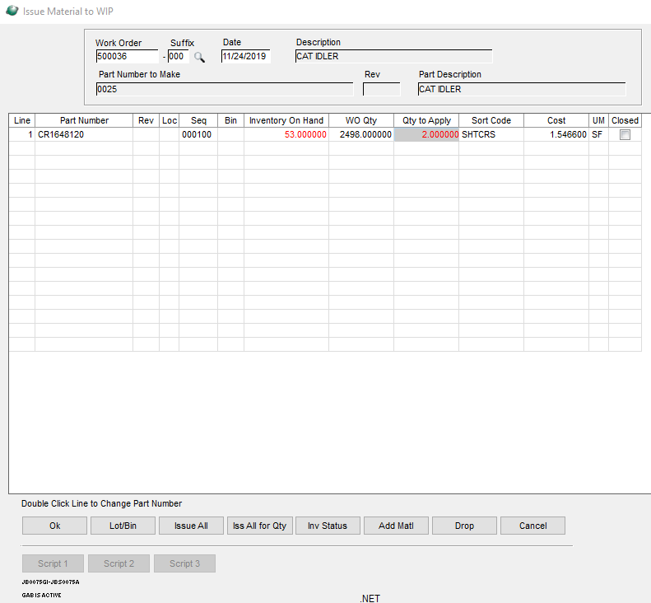

Click OK, the custom WIP BIN will pop up. Select the WIP BIN from the dropdown list of the Bin column or by the Browser of the Brw column.

+ Bin Qty: current quantity of the part in that Bin. This is the total of that part number for all the Job Sequences assigned to that Bin.

+ Assigned Qty is the quantity we issued in the previous screen.

+ New Qty = Bin Qty + Assigned Qty.

The dropdown list will display current BINs linked to that Job while the Browser will display all WIP BINs

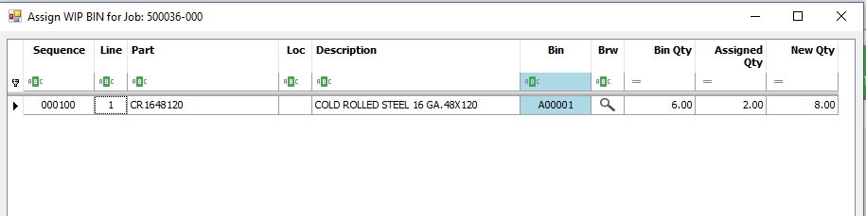

Click Close

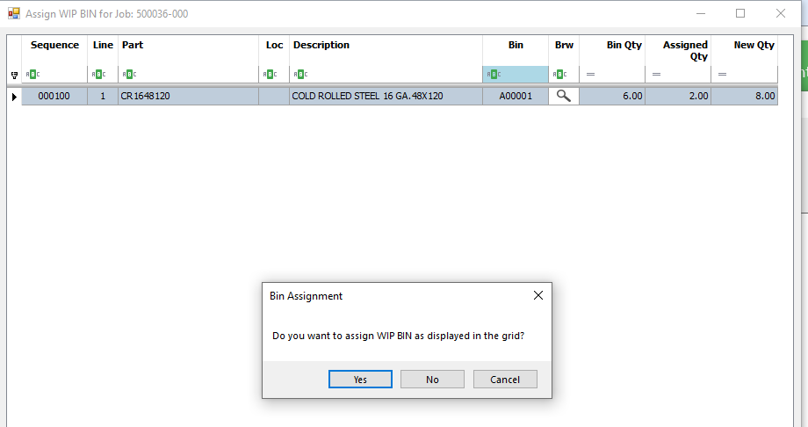

At GUI, select a Job, the Bin column will be displayed the WIP BINs at the Material sequences if those sequences were assigned at Issue Material.

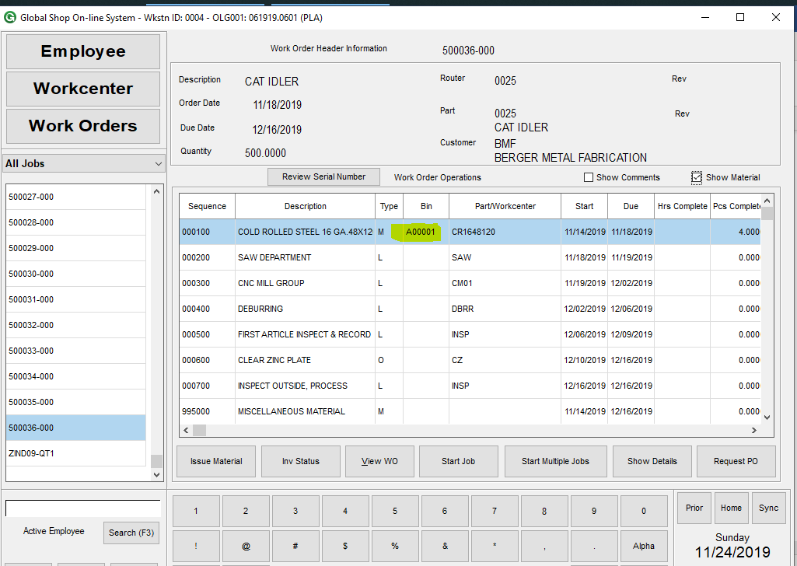

**2/ GS Mobile: 2 custom transactions are added to GS Mobile:**

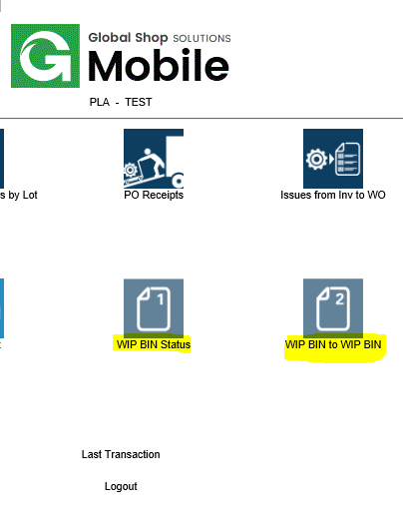

**2.1 WIP BIN Status:**

Scan a Job Sequence, display all WIP BINs of that Job:

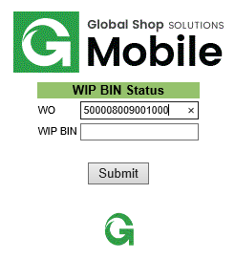 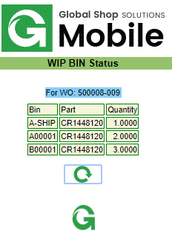

Scan the WIP BIN, display all the parts and Job Sequences that are assigned to that WIP BIN:

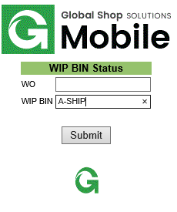 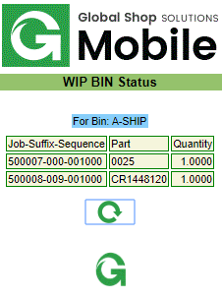

Validation:

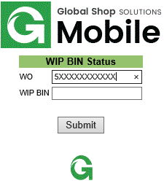 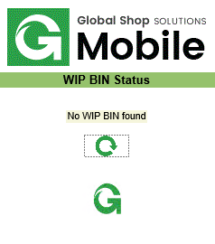

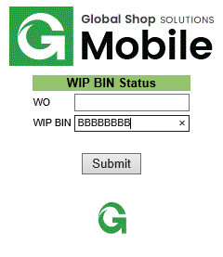 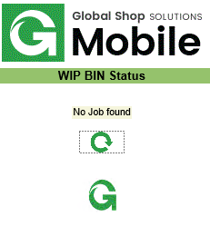

**2.2/ Move Job Sequences from WIP BIN to WIP BIN:**

